LAB SESSION: 03
(Doubly Linked List Operations)

Class of Node: Print Funtion:
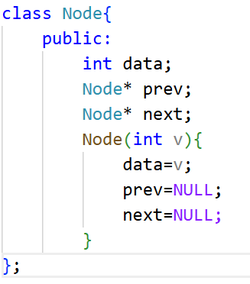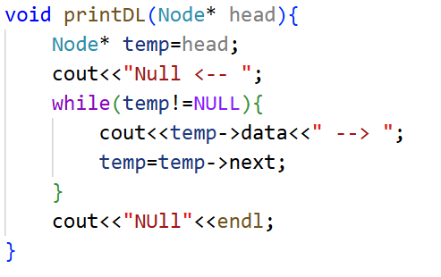
- Implement the above algorithms in C++.
CODE:
Traversal
Forward Backward
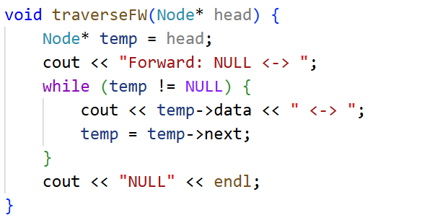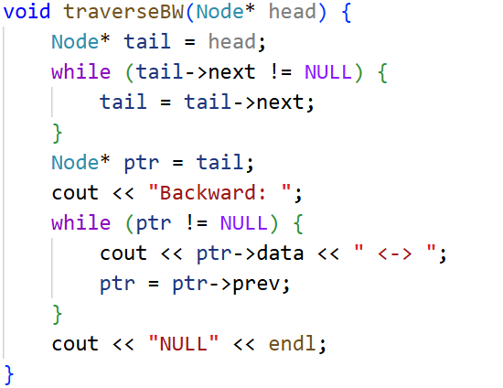
Output
Insertion
Insertion at Beginning Insertion at End
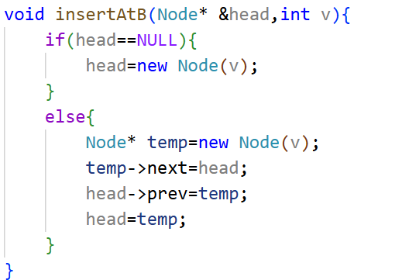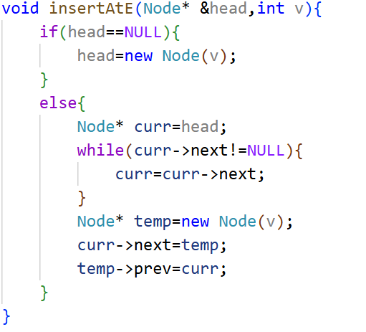
Insertion at Position (pos)
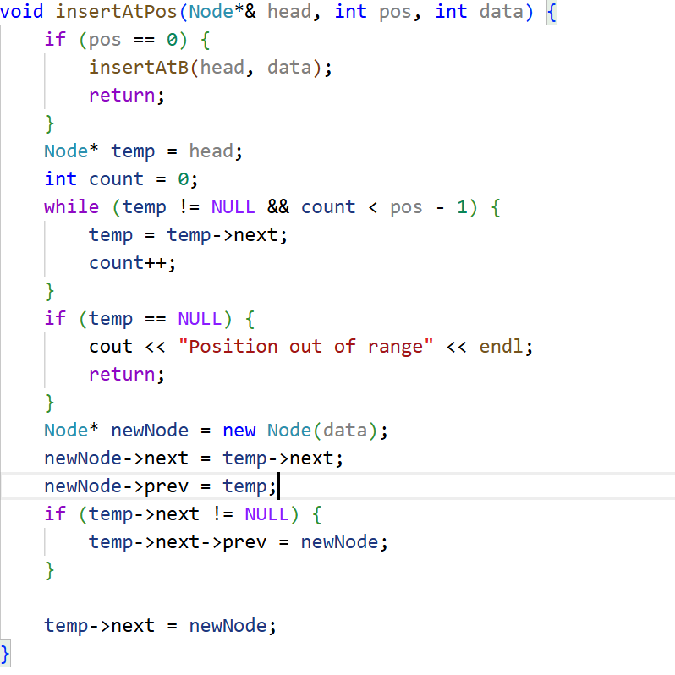
Deletion
Deletion at Beginning Deletion at End
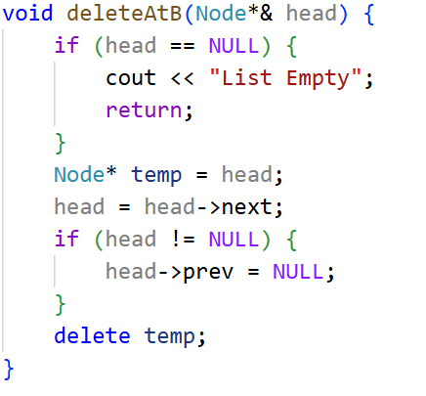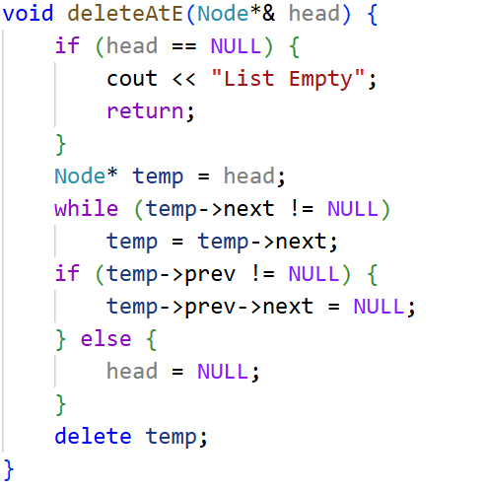
Deletion at Position (pos)
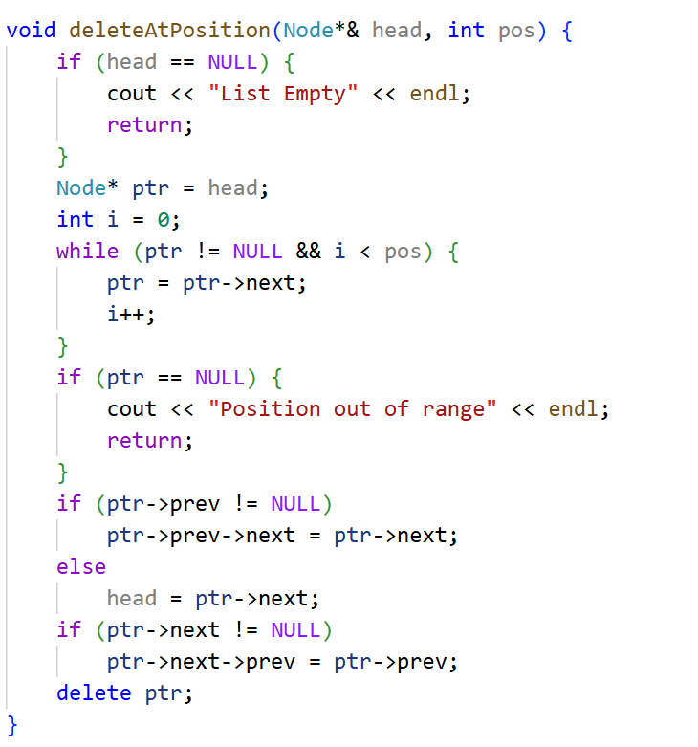
- Add a search function to find a given value.
CODE:
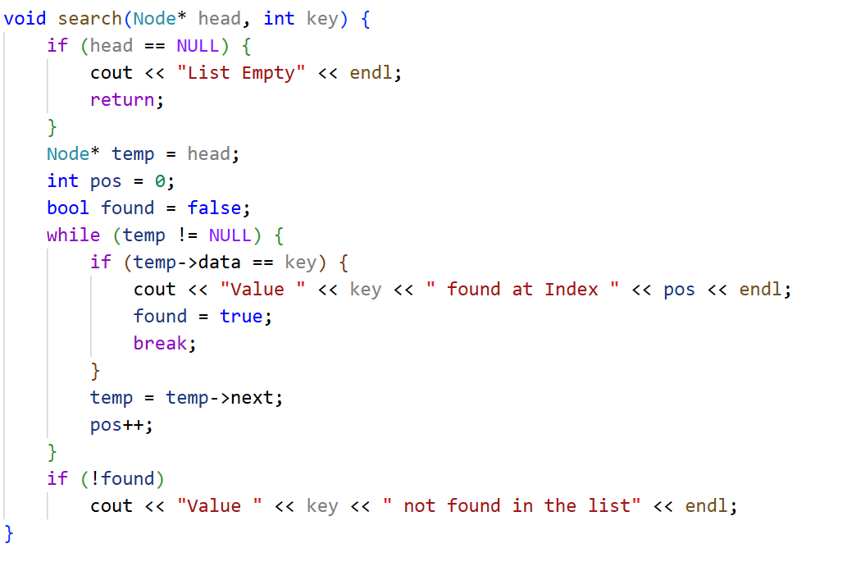

Output
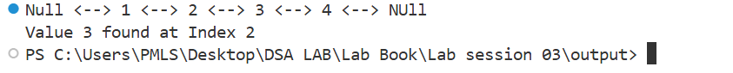

- Write a function to count the total number of nodes in the DLL.
CODE:
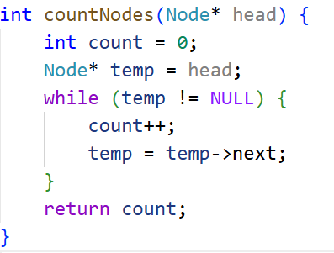

OUTPUT:

- Modify insertAtPosition() to handle inserting at the last position without using
insertAtEnd().
CODE:
void insertAtPos(Node*& head, int pos, int data) {
Node* newNode = new Node(data);
if (pos == 0 || head == NULL) {
newNode->next = head;
if (head != NULL)
head->prev = newNode;
head = newNode;
return;
}

Node* temp = head;
int count = 0;

while (temp->next != NULL && count < pos - 1) {
temp = temp->next;
count++;
}

if (temp->next == NULL && count < pos - 1) {
cout << "Position out of range" << endl;
delete newNode;
return;
}

if (temp->next == NULL) {
temp->next = newNode;
newNode->prev = temp;
return;
}

newNode->next = temp->next;
newNode->prev = temp;
temp->next->prev = newNode;
temp->next = newNode;
}

OUTPUT:

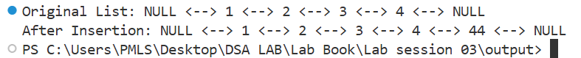

- Modify deleteAtPosition() to handle deletion from the last position without calling
deleteAtEnd().
CODE:
void deleteAtPosition(Node*& head, int pos) {
if (head == NULL) {
cout << "List Empty" << endl;
return;
}

Node* temp = head;
int count = 0;

while (temp != NULL && count < pos) {
temp = temp->next;
count++;
}

if (temp == NULL) {
cout << "Position out of range" << endl;
return;
}

if (temp->prev != NULL)
temp->prev->next = temp->next;
else
head = temp->next;

if (temp->next != NULL)
temp->next->prev = temp->prev;

delete temp;
}
OUTPUT:
- Implement a function to reverse a doubly linked list:

CODE:
void reverseDLL(Node*& head) {
if (head == NULL || head->next == NULL)
return;

Node* left = head;
Node* right = head;

while (right->next != NULL)
right = right->next;

while (left != right && left->prev != right) {
int temp = left->data;
left->data = right->data;
right->data = temp;

left = left->next;
right = right->prev;
}
}

OUTPUT:

- Implement a function to merge two DLLs.
CODE
void mergeDLL(Node*& head1, Node*& head2) {
if (head1 == NULL) {
head1 = head2;
return;
}
if (head2 == NULL) {
return;
}
Node* temp = head1;
while (temp->next != NULL)
temp = temp->next;
temp->next = head2;
head2->prev = temp;
}
int main() {
Node* head1 = new Node(1);
Node* second1 = new Node(2);
Node* third1 = new Node(3);
head1->next = second1;
second1->prev = head1;
second1->next = third1;
third1->prev = second1;
Node* head2 = new Node(4);
Node* second2 = new Node(5);
head2->next = second2;
second2->prev = head2;

cout << "First List: ";
printDL(head1);
cout << "Second List: ";
printDL(head2);
mergeDLL(head1, head2);
cout << "Merged List: ";
printDL(head1);
}
- Create a menu-driven program to test all operations dynamically.

CODE

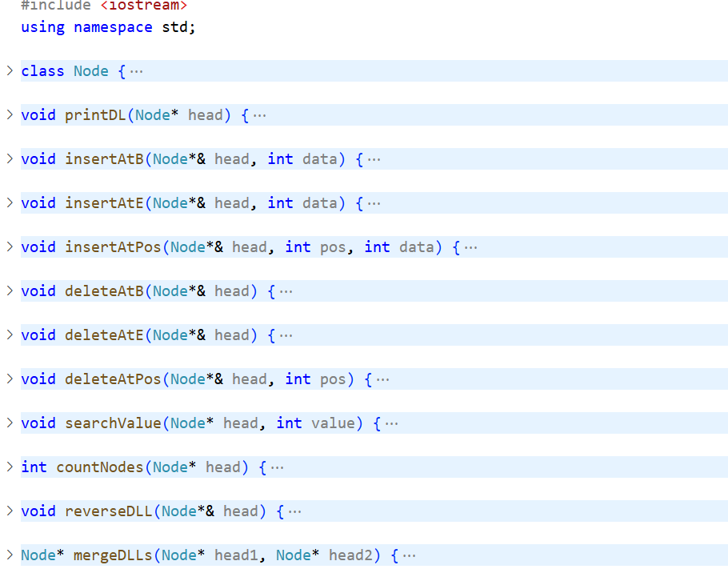

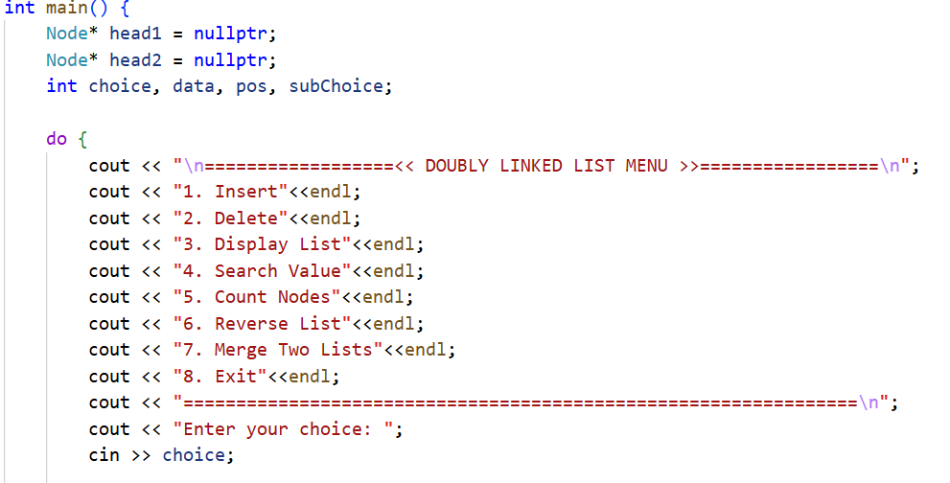

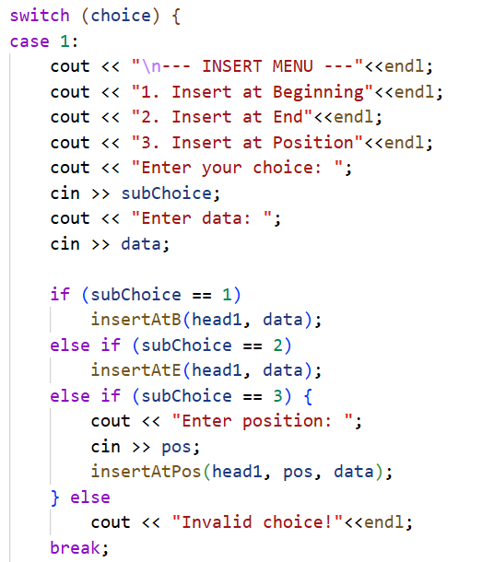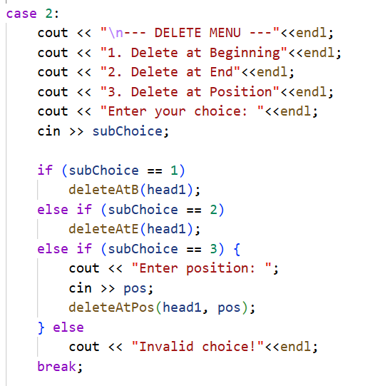

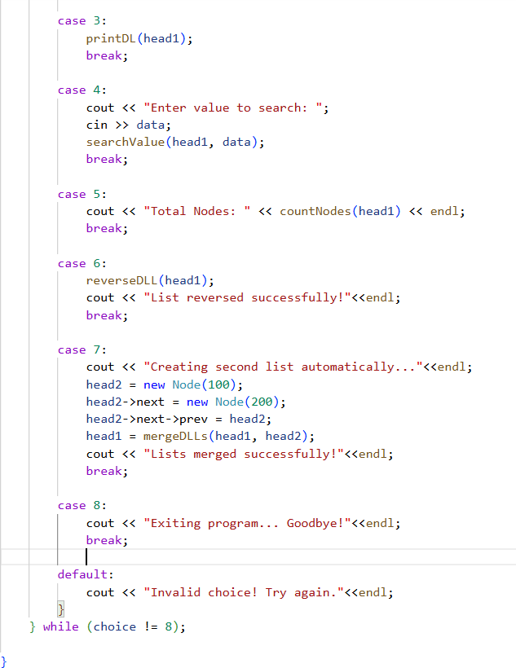

Output:

